Online Peer Mediation Project:

ONLINE PEER MEDIATION PLATFORM: TAKING PEER MEDIATION TO THE NEXT LEVEL

WHY “ONLINE” PEER MEDIATION?

All good ideas must adapt to their context to continue and to improve. Peer mediation is no exception. Since the mid-1980s, peer mediation has been the most commonly used conflict resolution education program in the United States. Research indicates that as many as 25% of US schools have had peer mediation programs serving grades 3-12 and many programs in large urban districts are district-wide (for example, Fairfax, VA; Laredo, TX; Cleveland, OH; San Francisco, CA.; Fresno, CA; and Broward County, FL).

However, there are three changes in the educational and social context that suggest the need for a more technologically sophisticated version of peer mediation. They are:

1 - Significant and increasing online public education
In formal educational contexts (K-12) the increase in online, virtual, and charter schools has skyrocketed. Approximately 3 million K- 12 students are currently enrolled in free, online public schools. These schools currently are not served by peer mediation or conflict resolution education efforts even though structurally they are easily adapted for these programs.

2 - Prevalence and preference for technologically supported communication
Technologically supported communication is the preference of the current school-age generation. For the millions of students in conventional K-12 schools, community groups, or youth organizations, the reality is that an online peer mediation opportunity is more congruent with their use of social media and communication technology. The simple truth is that kids use and prefer technologically mediated communication for a range of social uses and this should and can include conflict resolution through peer mediation. Social Networking Sites play an important role in the lives of many young people. Over 60% of 13-17 year olds have at least one profile on a social networking site, many spending more than 2 hours per day on social networking sites. More than half of children use social media by the age of 10. According to Pew Foundation research, over 93% of teenagers in the US have computers and mobile devices and use them for a majority of their social interaction.

3 - Global peer mediation growth
Peer mediation programs have been growing not only in the United States, but also around the world. In fact, much of the increase in peer mediation since 2000 has happened in Europe, Australia and South Asia.

WHAT IS ONLINE PEER MEDIATION PLATFORM (OPMP)?
For the reasons listed above, in December 2014 the JAMS Foundation funded our Online Peer Mediation Platform (OPMP), a 2-year project initially managed by the Association for Conflict Resolution, and now managed by the National Association of Peer Program Professionals.

To visit our website click here - http://goo.gl/gK45Vd

OPMP GOALS
The four goals of our Online Peer Mediation Platform are:

1 - Resources/Clearinghouse
Provide extensive information to anyone interested in peer mediation: useful links, resources, research, best practices, standards, curriculum, media. Click here ("Resources") http://goo.gl/gK45Vd

2 - Online Training in Basic Peer Mediation Skills
Show how middle/high schools can teach their students basic peer mediation skills online - (Available in 2016)

3 - Online Peer Mediation Skills Development
Teach middle/high schools how students can practice their peer mediation skills by participating in online peer mediation simulations with other students and their trainer. Each simulation consists of four parts:

- (Co)mediation of a typical school-related conflict between two or more students.
- Debriefing, to reflect on what happened during that peer mediation: what worked well or not-so-well, and why.
- Video Recording
- Online Survey, to collect all students' feedback: e.g. what they liked about their simulation, what the learned.

In 2015 we ran and video recorded six online mediation simulations. The results were very positive (students loved them). This is what Erin and Jada, two high school mediators, wrote:

"Online Peer Mediation conforms to a high schooler’s schedule, mediation can happen anytime, anywhere. You really sharpen your skills because you are not in the same (physical) space."

"Online Peer Mediation offers awesome flexibility. Technology is an advantage. This is a way to get an issued solved quickly… this is our scope of practice."

As a result, we are now seeking 10 middle or high schools in the USA that are interested to learn in 3 hours (for Free) how to set up, run and video record online simulations with their own students and trainer. To watch the video recordings of our six simulations and learn how middle/high schools can participate in our 3-hour "Train the Peer Mediation Trainer" program, click here - http://goo.gl/mj1fdt

4 - Online Peer Mediation Services
Show how middle/high schools experienced in peer mediation can deliver online peer mediation services to schools that don’t have a peer mediation program (Available in 2016)

WHO IS THE OPMP TEAM?
Our team is a group of experts in peer mediation, online mediation, Internet and mobile technology.

- Judy Tindall, Ph.D. - President, National Association of Peer Program Professionals
- Dr. Cynthia Morton - Chair of Education Research and Teaching Section, ACR
- Prof. Karen DeVoogd - MA, Director Mediator Mentors, California State University Fresno, Fresno CA
- Jay Edwards - Website Consultant,­ ReelFire Productions
- Giuseppe Leone - Founder, Virtual Mediation Lab
- Kristen Woodward - Conflict Resolution Specialist, Fairfax County Schools

HOW CAN I GET INVOLVED?
If your middle/high school is interested to participate in or learn more about our Online Peer Mediation Platform project, please send us an email - http://goo.gl/FJEdyw

Please Note: OPMP is initially available to middle/high schools in the USA, but later will also be available to schools around the world.

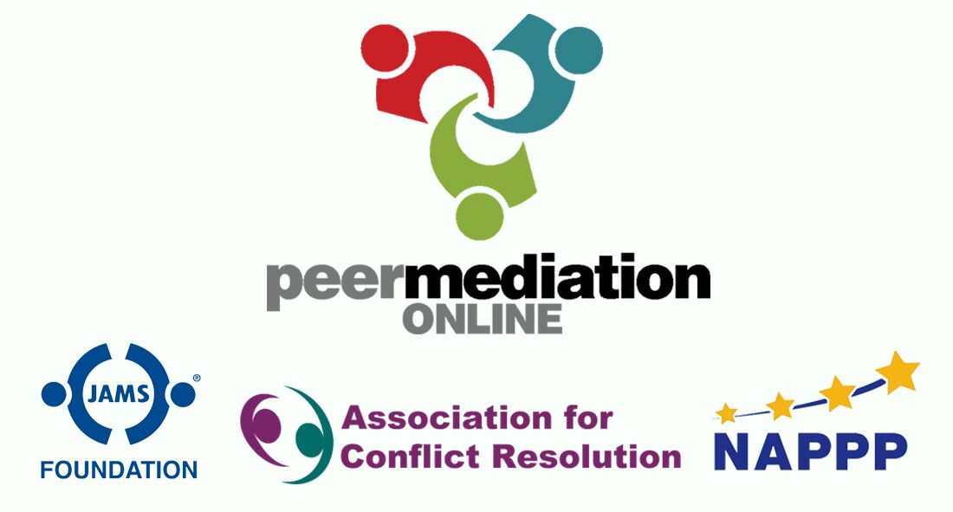
Judy Tindall, Ph.D.
National Association of Peer Program Professionals.

