The SMU Peer Helping Program-First International Certified Program
Connie Wong
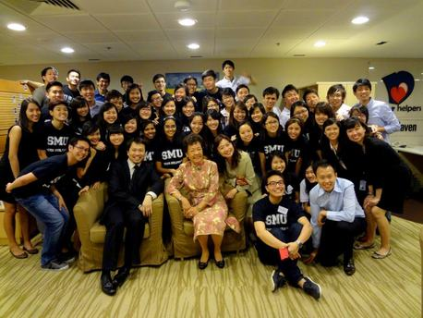
The Peer Helping program in the Singapore Management University (SMU) started in 2003 and has been at the forefront in the provision of mental health and wellness program amongst the student community in SMU. It is one of Singapore’s first and only formally-structured peer-helping program for the education sector.
The program has produced about 1,200 peer helpers to date, including those who graduated. Trained and supervised by the team of professional counselors from the university’s Counseling Centre, the peer helpers have sought to make a difference to the lives of students through outreach events and campaigns over the years, focusing on topics relevant to the overall wellness and well-being of the
student community, yet at the same time individually looking out for those who may face difficulty in handling the pressure of academic rigors or who may be overwhelmed by the challenges of student life. On 18th January 2013, “A Basic Guide on Peer Helping” – a book that
represents the collective effort of the counselors based on their shared experience of running the peer helping program - was launched in SMU. The book was distributed to all school counselors, and is currently he standard textbook for the general elective course “Peer Mentoring and Facilitation” in SMU. SMU President, Professor Arnoud De Meyer said, “While SMU has always focused on offering an outstanding education to our students, we also hope to nurture them as caring and responsible individuals. Over the years, our Peer Helping program has been effective in developing their ability to spot any fellow peers in distress and to lend a timely helping hand.”

